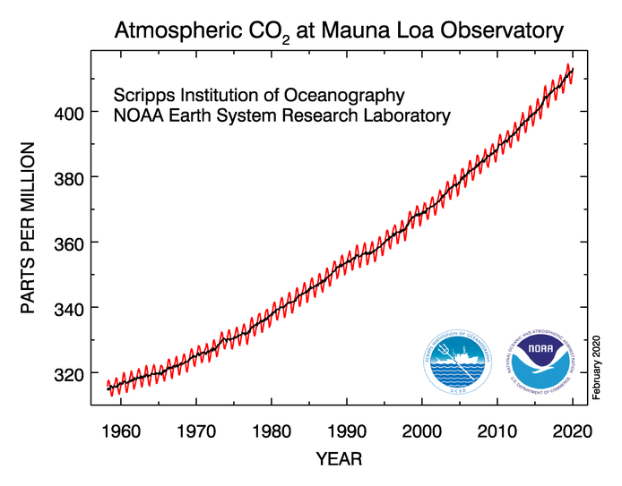
U.S. Department of Commerce - National Oceanic & Atmospheric Administration
Earth System Research Laboratory - Global Monitoring Division
https://www.esrl.noaa.gov/gmd/ccgg/trends/

Global Land Ocean Temperature Index
(For Same Period)
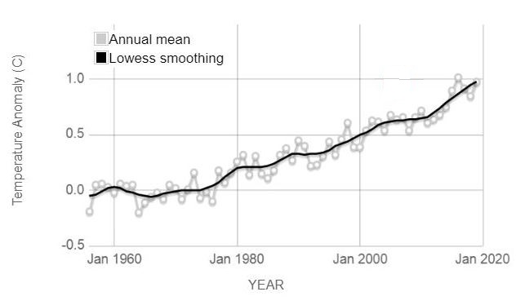
Data Source: NASA’s Goddard Institute for Space Studies
https://climate.nasa.gov/vital-signs/global-temperature/

STOP CARBON POLLUTION
STOP CLIMATE CHANGE

